Introduction
Contact Management provides a facility for users to simply record all their patient contacts from Telephone, Text, Face to Face and email. As part of Contact Management users will have the ability to publish a clinic letter or patient contact summary. All data entered within an established contact is linked allowing the system to consolidate the entered clinical data to populate the required letter or patient report.

Initial Access
When users access their patient’s record from within a Clinic patient population (mainly Secondary Care users) initially the patient’s record will be displayed in ‘read-only’ mode. Users will need to open an established or new contact in order to record any clinical data. Alternatively if the user wishes to process clinical data out with a contact then all that is required is a quick simple selection in the Contact Menu “Data Entry without Contact”.
The system will alert the user that the “Patient record is read-only. If you wish to enter data you must use the Contact menu to establish a contact or choose the option Data Entry without Contact.”
[This alert can be closed by selecting the cross]

Establishing a Contact
There are two ways to establish a new contact. The system can create a quick contact when the user selects contact type from the contacts menu or by accessing the Manage Contacts screen by selecting Manage Contacts from the Contact Menu. See below;
Selecting a contact type from the contacts menu will allow users to quickly establish one of the following contacts;

- Telephone Contact
- Face to Face Contact
- Email Contact
- Text Message Contact

Additionally the user would very quickly be able to access the last contact created for the patient record.

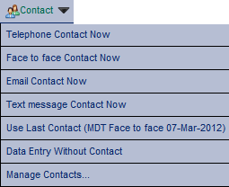
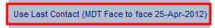

When any of the above contacts are selected from the contacts menu it will create an entry in the Manage contacts table. Data Items that are mandatory to each contact type are applied a predefined default setting, if required users can edit the recorded Contact information at a later date.

System Application Banner
The Systems application banner will highlight that the patient contact is in progress, and display the Contact Type and Date. The patient’s record will be linked to the established displayed contact and any changes or updates to the patient’s records will be grouped to the displayed contact, (and available to populate any pre defined letter or patient report if required).

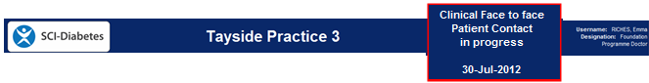

Manage Contacts Screen
To manually establish a new contact users are required to select “Add a new entry”, the screen will refresh and populate the table with a “Contact Data Entry Panel”. Users are required to complete the mandatory and relevant contact details and select “Save Entry”, to apply to the table if for future contact, “Save Entry & Use” if user wants to enter data straight away or “Cancel Update” if the user is no longer requiring the contact.
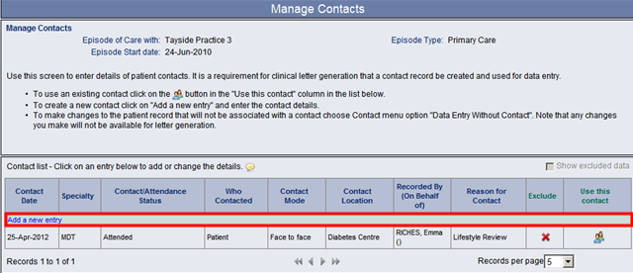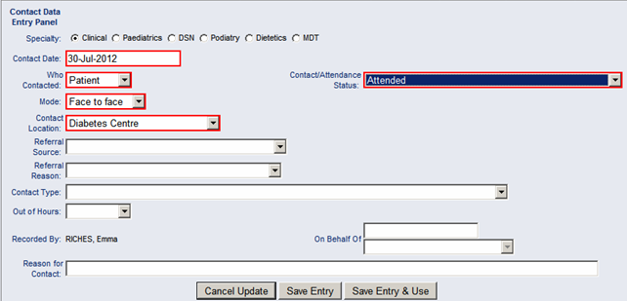

Updating an establish Contacts Details
Users are able to amend an established contact’s details. This is done by simply selecting the contact from the contacts table, the system displays the panel in EDIT Mode for the user to update, when the user has completed their update they will need to select “Modify Entry” to apply the changes to the established contact, “Modify Entry & Use” or “Cancel Update”.

User Options
For clinic domain users the system opens the patient record in read only mode and prompts the user to establish a contact to enable data entry. Users can opt to bypass this using their “Change User Options screen” and selecting the “Contact prompt not required” option once applied to the users account it will open the patient records in data entry mode. Below is a guide on how to conduct this process. Remember: If you wish the data you enter to appear on a Clinical Letter it must be entered with a contact established.

Navigate to the Change User Options Screen: Select the “Contact prompt not required” tick box:
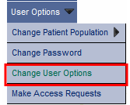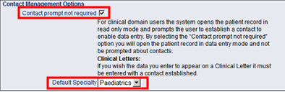
Default Specialty
For users who use the quick contact function in the “Contact Menu” selecting their specialty here will pre-populate all their future contacts to their selected specialty if this is not selected then the system default speciality “MDT” will be applied.

Glossary: SCI-Diabetes
- Selecting this icon will enable users to reinstate an excluded contact.
- Selecting this icon will enable users to exclude a clinical contact.
- Selecting this icon will allow the user to enter data within the selected established contact.
Selecting this tick box will refresh the table to include excluded data

